**TCES 312 Analog Electronic**

**Lab 4: Common Emitter Amplifier with Active Load**

**Ben Foster & Thinh Le**

**March 13, 2014**

1. Overview…………………………………………………..3
2. Circuit schematic and explanation………………………...3
3. Calculations………………………………………………..5

* Simulation
* Breadboard
* Theory

1. Data and Analysis……………………………………….7-8
2. Conclusion……………...……………………….………...8

**I. Overview**

The purpose of this lab is to create and analyze a Common Emitter amplifier with emitter degeneration that has a pnp current source in place of the collector resistor using theoretical calculations, a B2 Spice simulation, and breadboard measurements along with various complementary hardware pieces such as wires, resistors, capacitors, a 2N2222 npn transistor, and a SSM2220 matched pnp transistor pair. Lab instruments used include Circuit Specialists power supply, BK Precision signal generator, Agilent oscilloscope, and Fluke digital multimeter.

**II. Circuit Schematic and Explanation**

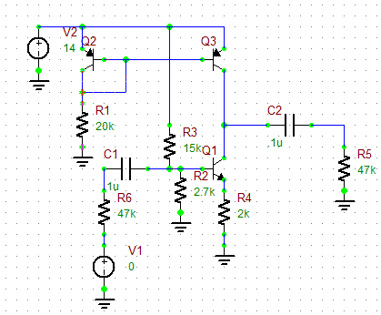

**Figure 1: Common Emitter amplifier with emitter degeneration and current source collector resistance (Rsig should be 2K).**

For this experiment, we use the 2N2222 npn transistor which has $β=220$ and ${ V}_{A}=104V$. We also use the SSM2220 matched pnp transistor pair where each transistor has $β=165$ and $V_{A}=42.41V$.

We were asked to closely pay attention to the DC voltage on the Q2-Q3 collector connection and adjust the DC bias of Q3 as necessary. While performing the breadboard part of the experiment, there was no distortion in the output voltage wave, therefore no adjustments were necessary.

As a part of our analysis, we also needed to find the output resistance of both the pnp current source and the npn CE transistor by DC measurements. The plots of current vs voltage are shown below in Figure 2 and 3. The slope of the linear portion of the graph is the inverse of the output resistance of the npn transistor (Figure 2) and the current mirror (Figure 3).

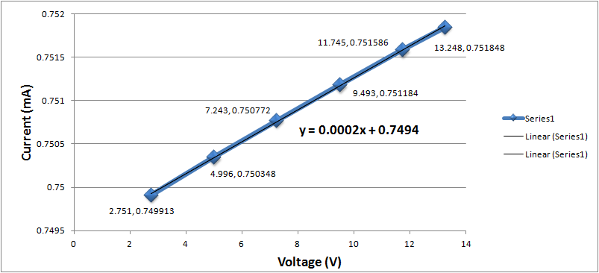

**Figure 2: Plot of npn output resistance by simulation**

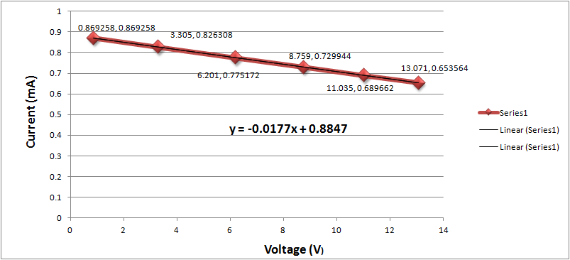

**Figure 3: Plot of pnp output resistance by simulation**

**III. Calculations**

**Simulation:** Most simulation data was found directly with tests without using any calculations. The only simulation data that needed any calculation were the gains, input resistance and output resistance. DC bias voltages and currents were measured in simulation by the DC bias test. Results are shown in Table 2.

When determining the output resistance, the same method was used for the simulation and breadboard. The current source and amplifier were separated and a load resistance was placed on the collector of Q3 for the current source and Q1 for the amplifier (refer to Figure 1 if needed). Using differing loads, a set of voltages at the collector and currents flowing through the collector resistor were plotted on a graph and the slope of the line was found. Rout for each was found by inverting the slope of the line. The graphs are shown in the previous section under graph 1 and 2 and the data used to find the graphs are in the next section under Table 1. All data in Table 1 was found using the DC bias test.

Equations used:

$R_{out}=R_{out,pnp}||R_{out,npn}$, where the two $R_{out}$’s were found from Figures 1 and 2.

$R_{in}={(A}_{v1}R_{sig})/A_{v}(1-A_{v1}/A_{v})$, where $R_{sig}$ is a value that we chose (around 2.3K) and $A_{v1}$ is the gain when there is a signal resistance and infinite load resistance.

$A_{v}=v_{out}/v_{in}$, where the input voltage is known and the output voltage is found from the AC sweep test.

$A_{overall}=v_{out}/v_{in}$, where there is a signal and load resistance involved.

Data that was found for simulation calculations and direct measurements are listed in Table 2 and 3 of the Data and Analysis section.

**Breadboard:** There was not much data that could be directly measured or calculated in the breadboard section. We could only measure the input voltage and output voltages of the signal and therefore determine the gain, as well as the input resistance and output resistance. When determining the output resistance, the same method was used for both the simulation and breadboard. DC voltage measurements were made with the Fluke multimeter. AC measurements were all done with the oscilloscope at 5-10 kHz.

Equations used:

All equations used for the breadboard were the same as the simulation.

Data that was found for the breadboard calculations are listed in Table 2 and 3 of the Data and Analysis section.

**Theoretical:** Theoretical calculations were done strictly on paper without using the simulation or the breadboard. All equations used were derived from lectures and/or analization. Theoretical calculations of DC parameters were made applying Kirchhoff’s laws to the amplifier circuit and then AC parameters were obtained using equations below.

Equations used:

.

.

)

.

.

= || (1 + || )

Av = (- $g_{m}R_{out}$) / (1+ $g_{m}R_{E}$)

$A_{overall}$ = Av ($R_{in}$/( $R_{sig}$ + $R_{in}$) $R_{load}$* /( $R_{out}$ + $R_{load}$)) , This equation was also used to find $R_{in}$ and $R_{load}$, which we used as approximations for simulation and breadboard calculations for $A_{overall}$.

Data that was found for theoretical calculations are listed in Table 2 and 3 of the Data and Analysis section.

**IV. Data and Analysis**

|  |  |  |  |  |  |  |
| --- | --- | --- | --- | --- | --- | --- |
| Current Source | Simulation |  |  |  | Breadboard |  |
| Resistor (K) | Voltage (V) | Current (mA) |  | Resistor (K) | Voltage (V) | Current (mA) |
| 1 | 0.869258 | 0.869258 |  | 0.9882 | 0.8458 | 0.8558996 |
| 4 | 3.305 | .826308 |  | 3.975 | 3.2678 | 0.822088 |
| 8 | 6.201 | .775172 |  | 7.941 | 6.204 | 0.7812618 |
| 12 | 8.759 | .729944 |  | 11.89 | 8.828 | 0.7424727 |
| 16 | 11.035 | .689662 |  | 15.861 | 11.191 | 0.705567 |
| 20 | 12.071 | .653564 |  | 19.968 | 13.276 | 0.66486 |
| CE Amp |  |  |  |  |  |  |
| 1 | 13.248 | .751848 |  | 0.9882 | 13.271 | 13.42947 |
| 3 | 11.745 | .751586 |  | 2.9742 | 11.750 | 3.950908 |
| 6 | 9.493 | .751184 |  | 5.957 | 9.466 | 1.589054 |
| 9 | 7.243 | .750772 |  | 8.9292 | 7.191 | 0.805353 |
| 12 | 4.996 | .750348 |  | 11.89 | 4.935 | 0.415055 |
| 15 | 2.751 | .749913 |  | 14.876 | 2.6688 | 0.179403 |

**Table 1: Data used to determine Rout.**

|  |  |  |  |
| --- | --- | --- | --- |
| Voltage & Current | Simulation | Breadboard | Theory |
| $$V_{B,npn}(V)$$ | 2.128 | 2.148 | 1.985 |
| $$V_{B,pnp}(V)$$ | 13.278 | 13.445 | 13.35 |
| $$V_{C}(V)$$ | 6.883 | 7.391 | 6.35 |
| $$V_{E}(V)$$ | 1.508 | 1.5217 | 1.335 |

**Table 2: Comparison of amplifier DC voltages and currents**

|  |  |  |  |
| --- | --- | --- | --- |
| Parameters | Simulation | Breadboard | Theory |
| $$g_{m}$$ | N/A | N/A | 28.42 |
| $$r_{o}(KΩ)$$ | N/A | N/A | 140.74 |
| $$R_{in}(KΩ)$$ | 2.277 | 2.3418 | 2.276 |
| $$R_{out}(KΩ)$$ | 55.92 | 63.694 | 62.92 |
| $$A_{v}$$ | 27.29 | 29.333 | 30.91 |
| $$A_{overall}$$ | 6.22 | 6.832 | 6.7225 |

**Table 3: Comparison of AC parameters**

All numbers in these tables were either directly measured on the breadboard, or taken directly from simulation or derived from the equations listed in the Calculations section.

**V. Conclusion**

In conclusion, the numbers that we originally produced using theoretical calculations closely matched the numbers that were produced from breadboard measurements. The simulation was slightly off, but still within a reasonable amount of error. Although slightly different numbers are expected, seeing how in reality, and even in simulation, certain aspects of the circuit vary slightly, such as extremely small resistances, equipment accuracy, human error, etc. However, since the numbers we compared together were pretty similar, we can conclude that we built the circuit on the breadboard and the simulation correctly.